Altruism Games - Dictator Game and the Ultimatum Game

Materials:

- Fake money: one £10 note, one £5 note, and five £1 coins, amounting to £20 per pair of participants.
- Qualtrics surveys to record the results from the games.

Preparation:
Emphasize that the decisions are anonymous and that the other participants will not know the decisions of their peers. This will help ensure that participants feel comfortable making decisions that accurately reflect their preferences.

Game One: Dictator’s Game (First round)
- Divide the participants into pairs.
- Within each pair, randomly assign one person to be the "Dictator" and the other person to be the "Receiver." This can be done by flipping a coin.
- Give each Dictator £20 in fake money.
- Explain to all participants that the Dictator must then decide how much, if any, to give to the Receiver. The Receiver has no say in this matter and must accept whatever amount the Dictator decides to give.
- Ask each Dictator to decide how much money they want to give to their paired Receiver.
- Direct the Dictators to write down the answer on a piece of paper.

Game Two: Ultimatum Game

- The pairs remain the same.
- Within each pair, randomly assign one person to be the "Proposer" and the other person to be the "Responder." This can be done by flipping a coin.
- The Proposers are given £20 in fake money.
- Explain that the Proposer propose how to split this amount between themselves and the Responder. The Responder can then either accept or reject this proposal. If the Responder accepts, the money is split as proposed. If the Responder rejects, both players get nothing.
- Ask each Proposer to decide how much money they want to offer to their paired Responder. Then, ask the Responders whether they accept or reject these proposals.
- Direct the Proposers and Responders to record their answers on a piece of paper.

Game Three: Dictator’s Game (Second round)

- Repeat Game One
- Record the results of all three games at Qualtrics

How to analyse the data

1. Organize Data

First, import your data into your statistical software. Ensure your data is structured consistently across all games. Your dataset might look something like this:

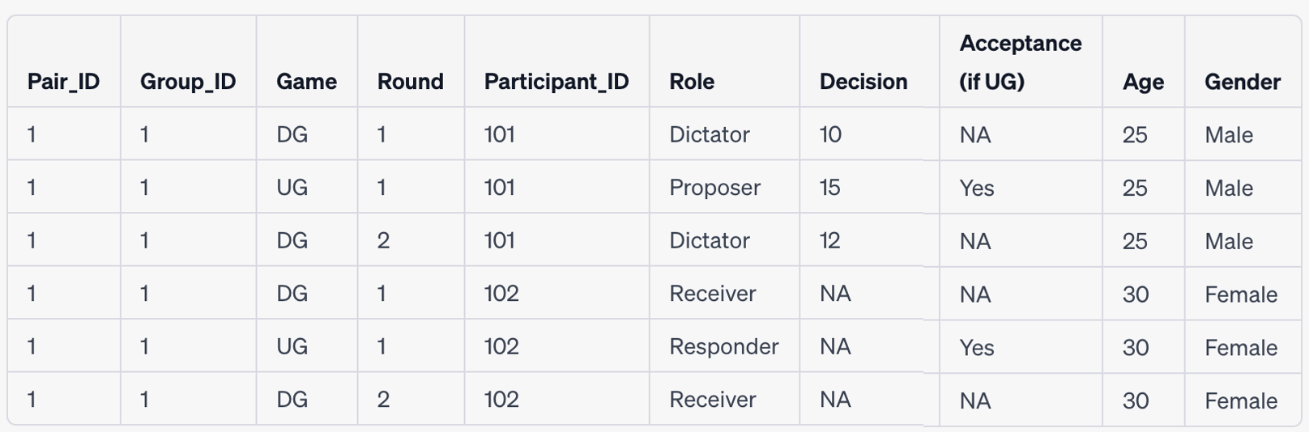
Note: The 'NA' entries mean that this field does not apply to that role in that game (e.g., Receivers in the Dictator Game do not make a decision). The Participant_ID is used to identify group membership.

2. Data Cleaning and Exploration

Check for any data entry errors, inconsistencies, or outliers. Compute summary statistics (mean, median, range, etc.) for the amount shared by the Dictators and Proposers in both games, as well as the acceptance rate in the Ultimatum Game. Create plots to visualize these distributions.

3. Compare DG1 and DG2

To examine whether there's a significant difference between the first and second rounds of the Dictator Game, you can perform a paired t-test (or Wilcoxon signed-rank test if the data is not normally distributed) using the 'Decision' variable. This will test the null hypothesis that the mean amount shared in DG1 is equal to the mean amount shared in DG2. Here are the STATA codes for the analysis.

ttest Decision, by(Round) paired

4. Role Switching Analysis

To examine whether switching roles between the two rounds of the Dictator Game made a difference, you can perform an independent sample t-test (or Mann-Whitney U test if the data is not normally distributed) comparing the 'Decision' variable between participants who switched roles and those who did not.

ttest Decision, by(RoleSwitch)

5. Ultimatum Game Analysis

For the Ultimatum Game, you might be interested in comparing the amount proposed by Proposers to the amount shared by Dictators in the Dictator Game. This can also be done with a paired t-test (or Wilcoxon signed-rank test).

To conduct this analysis, you will first need to reshape your data such that each pair has a single row with the Dictator's decision in the Dictator Game (DG) and the Proposer's decision in the Ultimatum Game (UG) as separate columns. If your data is not already structured this way, you can use the reshape command in STATA.

Once you have structured your data appropriately, you can compare the amount proposed by Proposers in the UG to the amount shared by Dictators in the DG using a paired t-test or Wilcoxon signed-rank test.

Let's assume your reshaped data looks something like this:

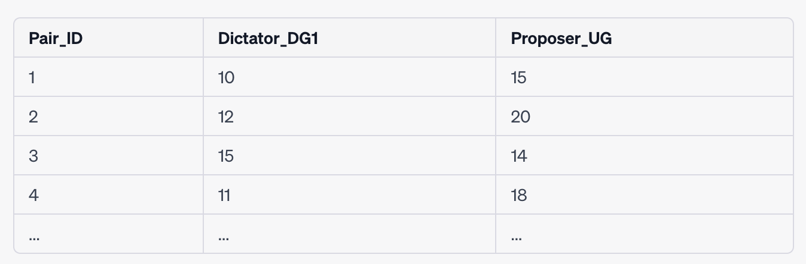

Here are the STATA commands:

Paired t-test:

ttest Dictator_DG1 == Proposer_UG, paired

This command conducts a paired t-test, comparing the amount shared by the Dictator in the first round of the DG to the amount proposed by the Proposer in the UG.

Wilcoxon signed-rank test:

signrank Dictator_DG1 == Proposer_UG

This command conducts a Wilcoxon signed-rank test, which is a non-parametric alternative to the paired t-test that does not assume normality. It compares the amount shared by the Dictator in the first round of the DG to the amount proposed by the Proposer in the UG.

In both cases, a significant result (p<0.05) would indicate a difference in the amounts proposed/shared in the two games.

In addition, you can examine the acceptance rate of the Responders. Are lower offers more likely to be rejected? To answer this question, you can perform a logistic regression with 'Acceptance' as the dependent variable and 'Decision' as the independent variable.

logit Acceptance Decision

6. Testing for Altruism

Finally, you might want to examine whether participants displayed altruism. One simple measure of altruism is whether the amount shared/proposed was greater than zero. You can calculate the percentage of participants who shared/proposed more than zero in each game.

Let's denote the Decision variable as decision and the Role variable as role. Here are the STATA commands to compute the percentages:

Percentage of participants who shared more than zero in the Dictator's game (round 1):

gen Dictator_DG1_GT0 = (decision > 0 & role=="Dictator" & game=="DG" & round==1)
tab Dictator_DG1_GT0, m

Percentage of participants who shared more than zero in the Dictator's game (round 2):

gen Dictator_DG2_GT0 = (decision > 0 & role=="Dictator" & game=="DG" & round==2)
tab Dictator_DG2_GT0, m

Percentage of participants who proposed more than zero in the Ultimatum game:

gen Proposer_UG_GT0 = (decision > 0 & role=="Proposer" & game=="UG")
tab Proposer_UG_GT0, m

In deciding between these measures, you'll want to consider what is most appropriate given your research question, the specifics of your experiment, and your sample size. Considering whether a person gave anything at all (i.e., a nonzero amount) is a commonly used, simple, and intuitive measure of altruism. It essentially captures whether a person was willing to give up any of their own resources to benefit someone else. However, it is somewhat crude as it does not differentiate between giving a small amount and giving a large amount. There are other, more nuanced ways of measuring altruism, as follow:

- Average amount given: Instead of just considering whether the amount given was nonzero, you could calculate the average amount given across all participants. This will give you a sense of how generous participants were on average. However, this measure could be influenced by a few very generous (or stingy) individuals.
- Percentage of endowment given: Another approach is to calculate the percentage of the initial endowment that each participant gave. This controls for variations in the size of the initial endowment, if any, and gives a sense of the proportion of their resources that participants were willing to share.

- Frequency of maximum giving: Count how often participants give all their endowment to the other player. This indicates extreme altruism.
- Prosocial behaviour index: Some researchers even use more complex prosocial behaviour indexes that incorporate multiple aspects of the individual's behavior across different tasks. This might include not just giving in the Dictator Game, but also behaviour in other games like the Ultimatum Game, Trust Game, etc. Creating such an index would require multiple observations for each participant across a variety of contexts.
- Econometric modelling: Finally, econometric models can be employed to estimate individual-specific parameters of altruism and fairness. This method typically requires a larger set of observations and a well-specified model of other-regarding preferences.

7. Influence of Age, Gender, and Group ID

To test the impact of age, gender, and group ID on the decisions, you can run a multiple regression with 'Decision' as the dependent variable and 'Age', 'Gender', and 'Group_ID' as the independent variables.

regress Decision Age Gender Group_ID

For the Ultimatum Game, you can also examine whether these variables influence the likelihood of accepting the proposal:

logit Acceptance Decision Age Gender Group_ID

The coefficients and p-values from these models can be used to determine the statistical significance and direction of these relationships. Interpretations of these results should be done in the light of existing literature and the specific context of your experiment.

